9/8/2019

Jordan

Solo Game developer

To Risk: Life or Limb

Design Document

Disclaimer: *Development of this project started around June 2019. This design document has been created on the September 8th, 2019. Not all features and/or planned features will be described in this document and therefore some information may be omitted accidentally or by choice.*

Contents

Project Overview 3

Level Generation 3

References 3

Overview of the design 4

The first design 5

Part 1 – Generating the level layout 5

Part 2 – Generating the places of interest 10

# Project Overview

To Risk: Life or Limb (abbreviated as RLoL) is a third-person action game with roguelike elements.

# Level Generation

## References

|  |  |
| --- | --- |
| Element | Description |
| Level Grid | A 2D (x, y) positioning system. |
| Node | The point on the level grid at which places of interest are generated. |
| Tile | A “building block”. Height of tiles will smoothly transition between each other. |
| Room | A group of tiles. A room can come in a variety of shapes such as a rectangle, circle, and hexagon. |

## Overview of the design

## The first design

### Part 1 – Generating the level layout

Step 1:

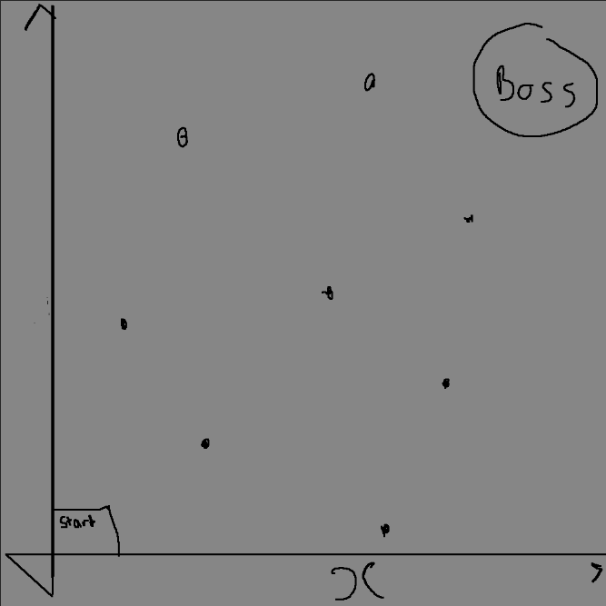

Generate the start room and the boss room. Also generate a number of rooms proportional to the area of the grid.

Step 2:

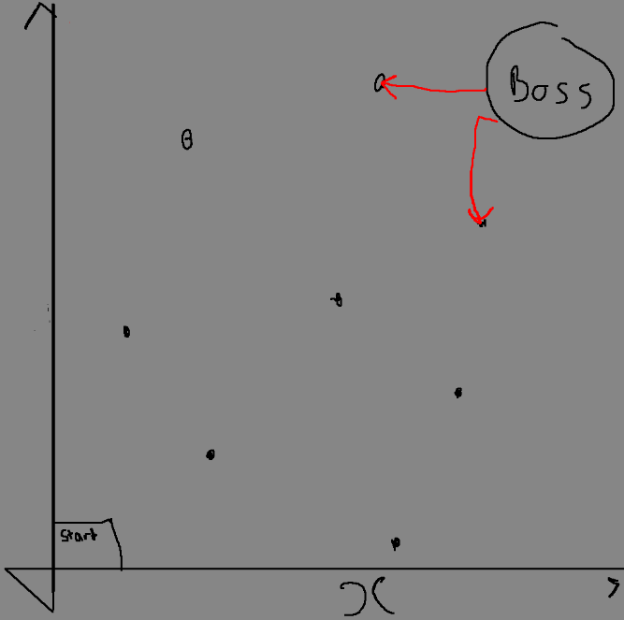

Working backwards from the final boss room, select the next two nodes closest to the start room.

Step 3:

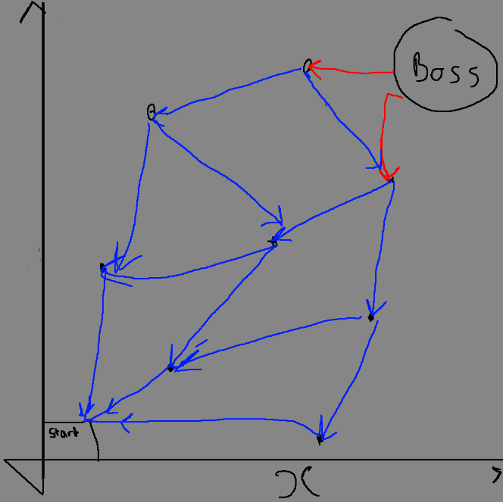

Iterate over each node, applying a similar process to step 2.

Step 4:

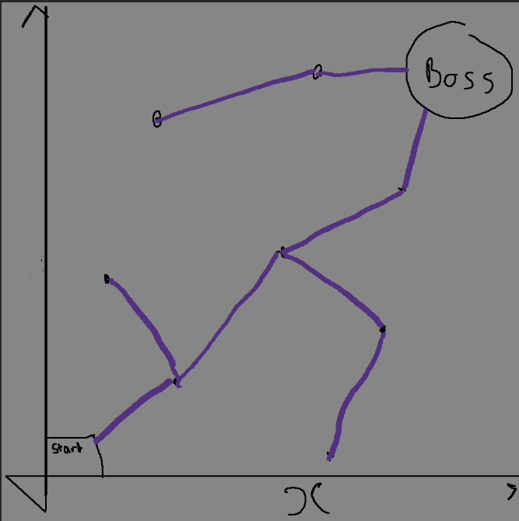

Generate the minimum spanning tree for the each place of interest (node and start/end areas) on the level grid.

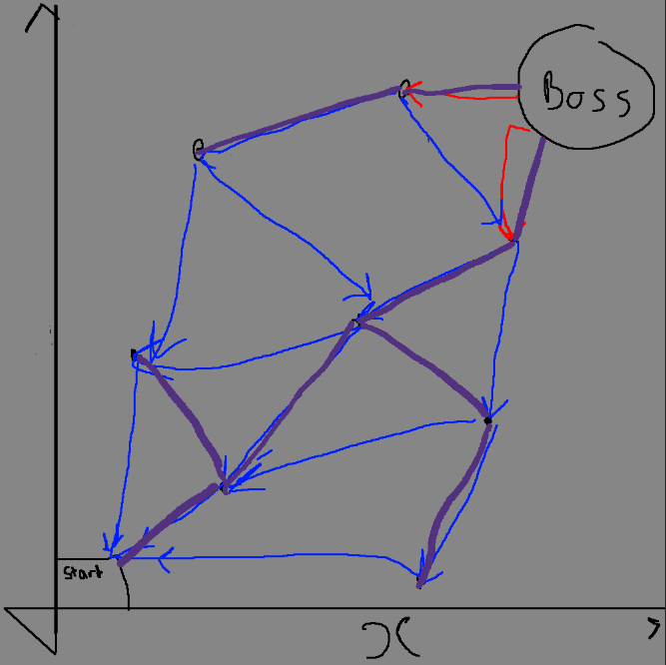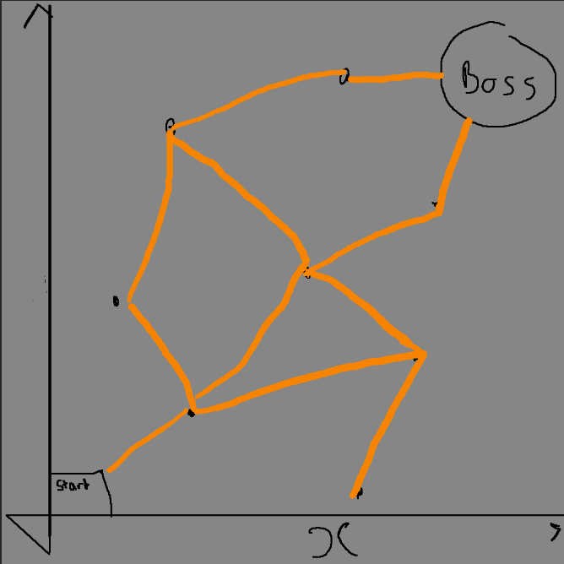Step 5:

Compare the minimum spanning tree with the paths generated in step 2 and 3. Have a percentage chance of removing a path if it is not on the minimum spanning tree.

The path through the level is now complete.

### Part 2 – Generating the places of interest

TO CONSIDER: create rooms in a spiral pattern around each node. Repeat until each node attempts to place a tile where one already exists

Step 6:

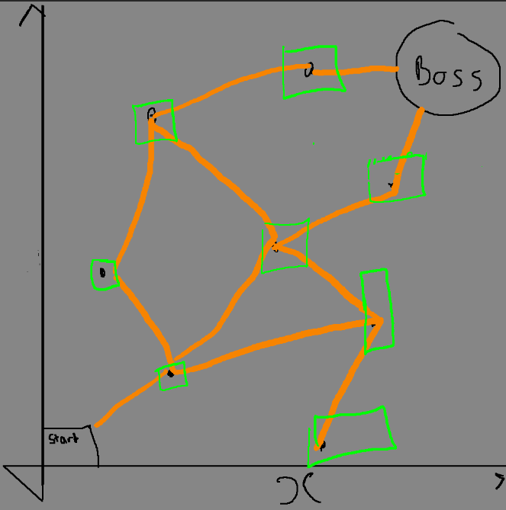

Create rooms at each node of random size

Step 7:

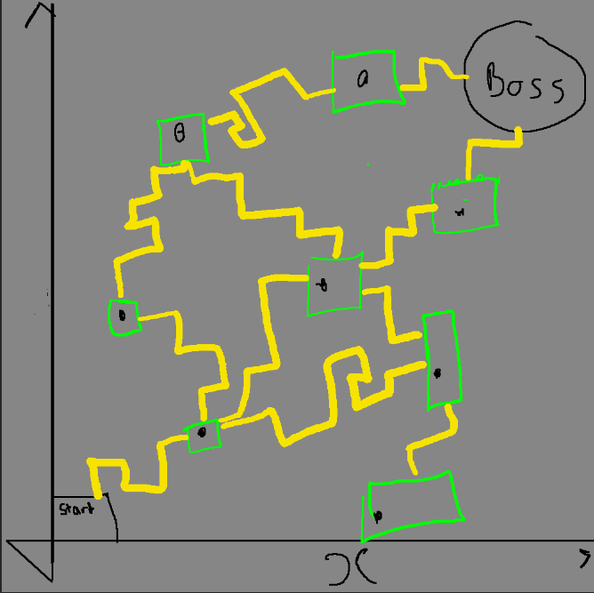

Generate pathways using a random walker along the path generated in step 5